Nama : Muhammad Raihan (17225119)

Ardhya Indra Rajasa (17225114)

Rendy Roviardi Permana (17225060)

Ricki Gilang Saputra (17225118)

Kelas : 17.2A.07

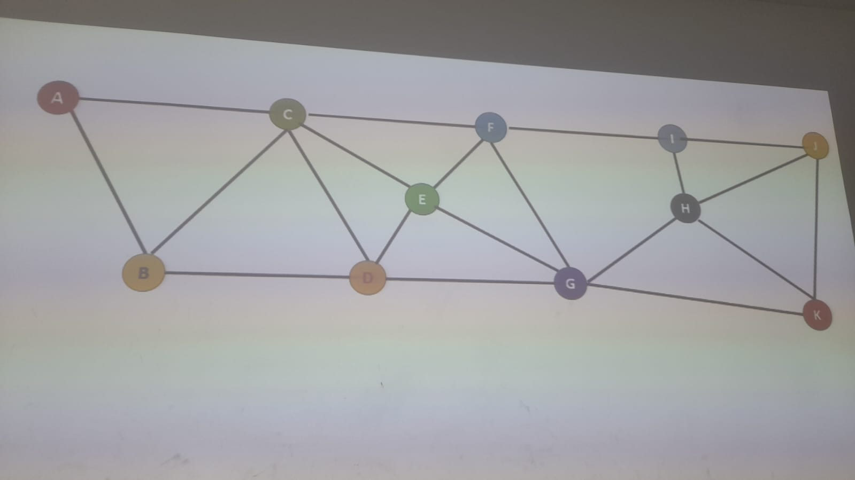

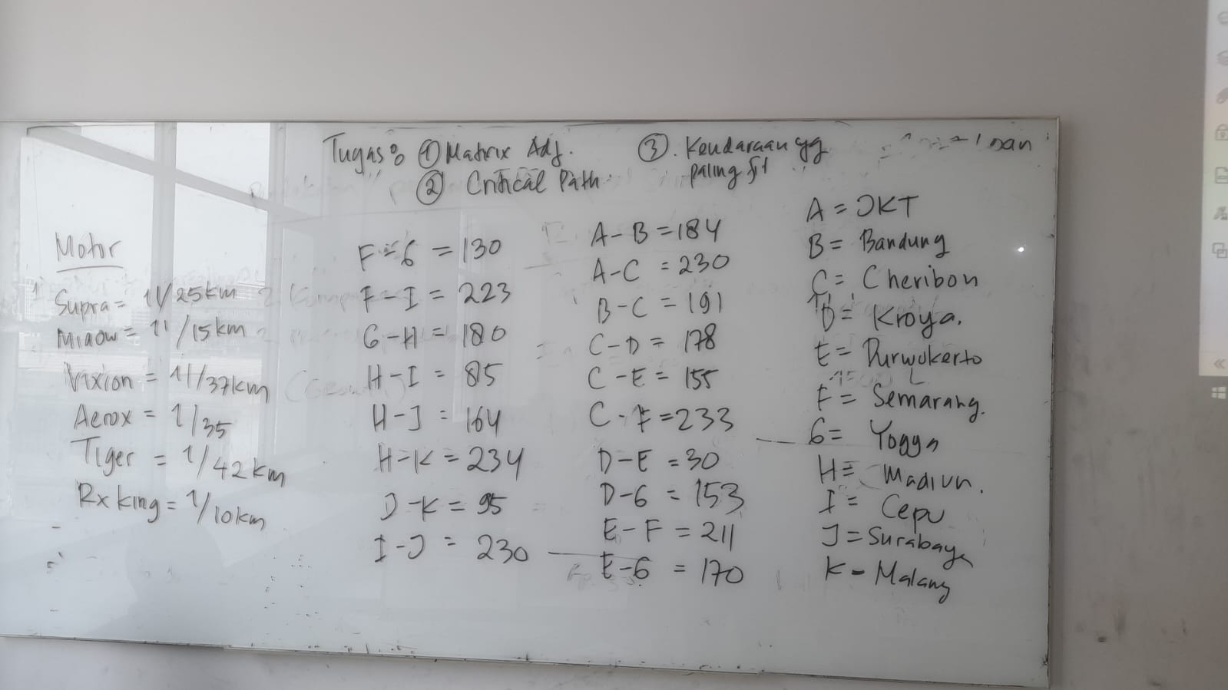

Tugas:

1. Matrix Adjacency
2. Critical Path
3. Shorth path

**Matriks Adjacency**

|  |  |  |  |  |  |  |  |  |  |  |  |
| --- | --- | --- | --- | --- | --- | --- | --- | --- | --- | --- | --- |
|  | **A** | **B** | **C** | **D** | **E** | **F** | **G** | **H** | **I** | **J** | **K** |
| **A** | 0 | 1 | 1 | 0 | 0 | 0 | 0 | 0 | 0 | 0 | 0 |
| **B** | 1 | 0 | 1 | 1 | 0 | 0 | 0 | 0 | 0 | 0 | 0 |
| **C** | 1 | 1 | 0 | 1 | 1 | 1 | 0 | 0 | 0 | 0 | 0 |
| **D** | 0 | 1 | 1 | 0 | 1 | 0 | 1 | 0 | 0 | 0 | 0 |
| **E** | 0 | 0 | 1 | 1 | 0 | 1 | 1 | 0 | 0 | 0 | 0 |
| **F** | 0 | 0 | 1 | 0 | 1 | 0 | 1 | 0 | 1 | 0 | 0 |
| **G** | 0 | 0 | 0 | 1 | 1 | 1 | 0 | 1 | 0 | 0 | 1 |
| **H** | 0 | 0 | 0 | 0 | 0 | 0 | 1 | 0 | 1 | 1 | 1 |
| **I** | 0 | 0 | 0 | 0 | 0 | 1 | 0 | 1 | 0 | 1 | 0 |
| **J** | 0 | 0 | 0 | 0 | 0 | 0 | 0 | 1 | 1 | 0 | 1 |
| **K** | 0 | 0 | 0 | 0 | 0 | 0 | 1 | 1 | 0 | 1 | 0 |

**Critical Path & Shortest Path**

|  |  |  |
| --- | --- | --- |
| **Cara** | **Path** | **Km** |
| **1** | A -> B -> C -> D -> E -> F -> G -> H -> I -> J -> K | 1514 |
| **2** | A -> B -> C -> D -> E -> F -> G -> H -> J -> K | 1363 |
| **3** | A -> B -> C -> D -> E -> F -> G -> H -> K | 1338 |
| **4** | A -> B -> C -> D -> E -> F -> I -> H -> J -> K | 1361 |
| **5** | A -> B -> C -> D -> E -> F -> I -> H -> K | 1336 |
| **6** | A -> B -> C -> D -> E -> F -> I -> J -> H -> K | 1645 |
| **7** | A -> B -> C -> D -> E -> F -> I -> J -> K | 1342 |
| **8** | A -> B -> C -> D -> E -> G -> F -> I -> H -> J -> K | 1450 |
| **9** | A -> B -> C -> D -> E -> G -> F -> I -> H -> K | 1425 |
| **10** | A -> B -> C -> D -> E -> G -> F -> I -> J -> H -> K | 1734 |
| **11** | A -> B -> C -> D -> E -> G -> F -> I -> J -> K | 1431 |
| **12** | A -> B -> C -> D -> E -> G -> H -> I -> J -> K | 1343 |
| **13** | A -> B -> C -> D -> E -> G -> H -> J -> K | 1192 |
| **14** | A -> B -> C -> D -> E -> G -> H -> K | 1167 |
| **15** | A -> B -> C -> D -> G -> E -> F -> I -> H -> J -> K | 1645 |
| **16** | A -> B -> C -> D -> G -> E -> F -> I -> H -> K | 1629 |
| **17** | A -> B -> C -> D -> G -> E -> F -> I -> J -> H -> K | 1938 |
| **18** | A -> B -> C -> D -> G -> E -> F -> I -> J -> K | 1635 |
| **19** | A -> B -> C -> D -> G -> F -> I -> H -> J -> K | 1403 |
| **20** | A -> B -> C -> D -> G -> F -> I -> H -> K | 1378 |
| **21** | A -> B -> C -> D -> G -> F -> I -> J -> H -> K | 1687 |
| **22** | A -> B -> C -> D -> G -> F -> I -> J -> K | 1384 |
| **23** | A -> B -> C -> D -> G -> H -> I -> J -> K | 1296 |
| **24** | A -> B -> C -> D -> G -> H -> J -> K | 1145 |
| **25** | A -> B -> C -> D -> G -> H -> K | 1120 |
| **26** | A -> B -> C -> E -> D -> G -> F -> I -> H -> J -> K | 1410 |
| **27** | A -> B -> C -> E -> D -> G -> F -> I -> H -> K | 1385 |
| **28** | A -> B -> C -> E -> D -> G -> F -> I -> J -> H -> K | 1694 |
| **29** | A -> B -> C -> E -> D -> G -> F -> I -> J -> K | 1391 |
| **30** | A -> B -> C -> E -> D -> G -> H -> I -> J -> K | 1303 |
| **31** | A -> B -> C -> E -> D -> G -> H -> J -> K | 1152 |
| **32** | A -> B -> C -> E -> D -> G -> H -> K | 1127 |
| **33** | A -> B -> C -> E -> F -> G -> H -> I -> J -> K | 1461 |
| **34** | A -> B -> C -> E -> F -> G -> H -> J -> K | 1310 |
| **35** | A -> B -> C -> E -> F -> G -> H -> K | 1285 |
| **36** | A -> B -> C -> E -> F -> I -> H -> J -> K | 1308 |
| **37** | A -> B -> C -> E -> F -> I -> H -> K | 1283 |
| **38** | A -> B -> C -> E -> F -> I -> J -> H -> K | 1592 |
| **39** | A -> B -> C -> E -> F -> I -> J -> K | 1289 |
| **40** | A -> B -> C -> E -> G -> F -> I -> H -> J -> K | 1397 |
| **41** | A -> B -> C -> E -> G -> F -> I -> H -> K | 1372 |
| **42** | A -> B -> C -> E -> G -> F -> I -> J -> H -> K | 1681 |
| **43** | A -> B -> C -> E -> G -> F -> I -> J -> K | 1378 |
| **44** | A -> B -> C -> E -> G -> H -> I -> J -> K | 1290 |
| **45** | A -> B -> C -> E -> G -> H -> J -> K | 1139 |
| **46** | A -> B -> C -> E -> G -> H -> K | 1114 |
| **47** | A -> B -> C -> F -> E -> D -> G -> H -> I -> J -> K | 1592 |
| **48** | A -> B -> C -> F -> E -> D -> G -> H -> J -> K | 1441 |
| **49** | A -> B -> C -> F -> E -> D -> G -> H -> K | 1416 |
| **50** | A -> B -> C -> F -> E -> G -> H -> I -> J -> K | 1579 |
| **51** | A -> B -> C -> F -> E -> G -> H -> J -> K | 1428 |
| **52** | A -> B -> C -> F -> E -> G -> H -> K | 1403 |
| **53** | A -> B -> C -> F -> G -> H -> I -> J -> K | 1328 |
| **54** | A -> B -> C -> F -> G -> H -> J -> K | 1177 |
| **55** | A -> B -> C -> F -> G -> H -> K | 1152 |
| **56** | A -> B -> C -> F -> I -> H -> J -> K | 1175 |
| **57** | A -> B -> C -> F -> I -> H -> K | 1150 |
| **58** | A -> B -> C -> F -> I -> J -> H -> K | 1459 |
| **59** | A -> B -> C -> F -> I -> J -> K | 1156 |
| **60** | A -> C -> D -> E -> F -> G -> H -> I -> J -> K | 1369 |
| **61** | A -> C -> D -> E -> F -> G -> H -> J -> K | 1218 |
| **62** | A -> C -> D -> E -> F -> G -> H -> K | 1193 |
| **63** | A -> C -> D -> E -> F -> I -> H -> J -> K | 1216 |
| **64** | A -> C -> D -> E -> F -> I -> H -> K | 1191 |
| **65** | A -> C -> D -> E -> F -> I -> J -> H -> K | 1500 |
| **66** | A -> C -> D -> E -> F -> I -> J -> K | 1197 |
| **67** | A -> C -> D -> E -> G -> F -> I -> H -> J -> K | 1305 |
| **68** | A -> C -> D -> E -> G -> F -> I -> H -> K | 1280 |
| **69** | A -> C -> D -> E -> G -> F -> I -> J -> H -> K | 1589 |
| **70** | A -> C -> D -> E -> G -> F -> I -> J -> K | 1286 |
| **71** | A -> C -> D -> E -> G -> H -> I -> J -> K | 1198 |
| **72** | A -> C -> D -> E -> G -> H -> J -> K | 1047 |
| **73** | A -> C -> D -> E -> G -> H -> K | 1022 |
| **74** | A -> C -> D -> G -> E -> F -> I -> H -> J -> K | 1509 |
| **75** | A -> C -> D -> G -> E -> F -> I -> H -> K | 1484 |
| **76** | A -> C -> D -> G -> E -> F -> I -> J -> H -> K | 1793 |
| **77** | A -> C -> D -> G -> E -> F -> I -> J -> K | 1490 |
| **78** | A -> C -> D -> G -> F -> I -> H -> J -> K | 1258 |
| **79** | A -> C -> D -> G -> F -> I -> H -> K | 1233 |
| **80** | A -> C -> D -> G -> F -> I -> J -> H -> K | 1542 |
| **81** | A -> C -> D -> G -> F -> I -> J -> K | 1239 |
| **82** | A -> C -> D -> G -> H -> I -> J -> K | 1151 |
| **83** | A -> C -> D -> G -> H -> J -> K | 1000 |
| **84** | A -> C -> D -> G -> H -> K | 975 |
| **85** | A -> C -> E -> D -> G -> F -> I -> H -> J -> K | 1265 |
| **86** | A -> C -> E -> D -> G -> F -> I -> H -> K | 1240 |
| **87** | A -> C -> E -> D -> G -> F -> I -> J -> H -> K | 1549 |
| **88** | A -> C -> E -> D -> G -> F -> I -> J -> K | 1246 |
| **89** | A -> C -> E -> D -> G -> H -> I -> J -> K | 1158 |
| **90** | A -> C -> E -> D -> G -> H -> J -> K | 1007 |
| **91** | A -> C -> E -> D -> G -> H -> K | 982 |
| **92** | A -> C -> E -> F -> G -> H -> I -> J -> K | 1316 |
| **93** | A -> C -> E -> F -> G -> H -> J -> K | 1165 |
| **94** | A -> C -> E -> F -> G -> H -> K | 1140 |
| **95** | A -> C -> E -> F -> I -> H -> J -> K | 1163 |
| **96** | A -> C -> E -> F -> I -> H -> K | 1138 |
| **97** | A -> C -> E -> F -> I -> J -> H -> K | 1447 |
| **98** | A -> C -> E -> F -> I -> J -> K | 1144 |
| **99** | A -> C -> E -> G -> F -> I -> H -> J -> K | 1252 |
| **100** | A -> C -> E -> G -> F -> I -> H -> K | 1227 |
| **101** | A -> C -> E -> G -> F -> I -> J -> H -> K | 1536 |
| **102** | A -> C -> E -> G -> F -> I -> J -> K | 1233 |
| **103** | A -> C -> E -> G -> H -> I -> J -> K | 1145 |
| **104** | A -> C -> E -> G -> H -> J -> K | 994 |
| **105** | A -> C -> E -> G -> H -> K | 969 |
| **106** | A -> C -> F -> E -> D -> G -> H -> I -> J -> K | 1447 |
| **107** | A -> C -> F -> E -> D -> G -> H -> J -> K | 1296 |
| **108** | A -> C -> F -> E -> D -> G -> H -> K | 1271 |
| **109** | A -> C -> F -> E -> G -> H -> I -> J -> K | 1434 |
| **110** | A -> C -> F -> E -> G -> H -> J -> K | 1283 |
| **111** | A -> C -> F -> E -> G -> H -> K | 1258 |
| **112** | A -> C -> F -> G -> H -> I -> J -> K | 1183 |
| **113** | A -> C -> F -> G -> H -> J -> K | 1032 |
| **114** | A -> C -> F -> G -> H -> K | 1007 |
| **115** | A -> C -> F -> I -> H -> J -> K | 1030 |
| **116** | A -> C -> F -> I -> H -> K | 1005 |
| **117** | A -> C -> F -> I -> J -> H -> K | 1314 |
| **118** | A -> C -> F -> I -> J -> K | 1011 |

Diperoleh :

Critical Path A - K ( Lintasan Kritis ) = 1938 km

Shortest Path A - K ( Lintasan Terpendek ) = 969 km

Diketahui :

Supra = 1L/25km

Mio = 1L/15km

Vixion = 1L/37km

Aerox = 1L/35km

Tiger = 1L/42km

Rx King = 1L/10km

Ditanya :

Bandingkan semua motor dengan menggunakan jarak Terpanjang dan Terpendek yang paling efisien dalam bahan bakarnya

Jika:

Critical Path A - K ( Lintasan Kritis ) = 1938 km & Shortest Path A - K ( Lintasan Terpendek ) = 969 km

Maka:

1Liter = n n = Jarak/Liter

JP = 1938 km JP = Jalur Panjang

JT = 969 km JT = Jalur Terpendek

Hitung Liter Jalur Terpanjang = JP / n = ….Liter

Hitung Liter Jalur Terpendek = JT / n =….Liter

|  |  |  |  |  |  |  |
| --- | --- | --- | --- | --- | --- | --- |
|  | **Supra** | **Mio** | **Vixion** | **Aerox** | **Tiger** | **Rx King** |
| **Terpanjang** | 77,52 L | 129,2 L | 52,38 L | 55.37 L | 46,14 L | 193,80 L |
| **Terpendek** | 38,76 L | 64,6 L | 26,19 L | 27,69 L | 23,07 L | 96,90 L |

Jadi motor dengan menggunakan jarak Terpanjang dan Terpendek yang paling efisien dalam bahan bakarnya adalah Tiger dengan jalur terpanjang menghabiskan = 46,14 L dengan jarak = 1938 km dan jalur terpendek menghabiskan = 23,07 L dengan jarak = 969 km